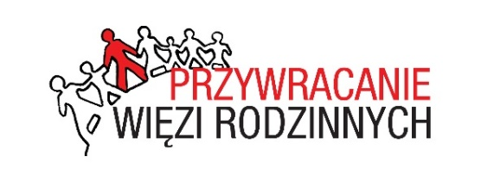
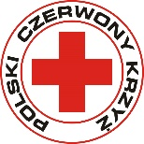

TRACING REQUEST

Sought Person:

Surname................................................................................................................................................................
(if applicable, also surname at birth and aliases)

First name/names..................................................................................................................................................

Parents' names......................................................................................................................................................
(and mother's maiden surname)

Date of birth........................................................ Place of birth...........................................................................

Occupation.................................................. Military rank and unit....................................................................

Nationality and citizenship...................................................................................................................................

Last known address..............................................................................................................................................
(telephone number)

Date and place of last news .................................................................................................................................

Other information concerning the Sought Person (circumstances of the loss of contact, field post number, names and addresses of persons who may have information about the person to be traced, workplace, personal information of family members, etc.)

Name all the institution you have approached

.............................................................................................................................................................................
Enquirer:

Surname................................................................................ First name.............................................................
(including surname at birth)

Date and place of birth........................................................................................................................................

Parents' names......................................................... Family relationship..........................................................
with the person to be traced

Address................................................................................................................................................................

Telephone number, e-mail....................................................................................................................................

Please write personal details in block letters. please turn over!

I agree to the processing of my abovementioned personal data by the Polish Red Cross in connection with a submitted application for tracing a person / persons or obtaining the attestation of the wartime fate.

I agree to forward my address to the National Red Cross / Red Crescent Societies as well as Arolsen Archives – International Center on Nazi Persecution, through which the search will be carried out and to the sought person or, if she/he is dead, to other relatives found or persons who have a relationship with the case.

Date …………………………………… Signature ………………………………….....................

According to Art.13 paragraph 1 of the General Data Protection Regulation of 27 April 2016, we inform that:

1) The administrator of your personal data is the Polish Red Cross, ul. Mokotowska 14, 00-561 Warsaw

2) Andrzej Antoń is the data protection inspector in the Polish Red Cross, e-mail address: iod@pck.org.pl

3) Your personal data will be processed in order to trace a person / persons or obtain the attestation of the wartime fate
on the basis of Art. 6 section 1 point a of the General Data Protection Regulation of 27 April 2016.

4) The recipient of your personal data will be the National Red Cross / Red Crescent Societies, the Arolsen Archives – International Center on Nazi Persecution and the Delegations of the International Committee of the Red Cross.

5) Your personal data will not be transferred to a third country / international organization.

6) Your personal data will be stored for the period of time necessary to complete the trace for a person / persons or to obtain
the attestation of the wartime fate, and also after its completion for purposes related to the archiving of data of the sought persons in the database managed by the Polish Red Cross.

7) You have the right to access your data and the right to rectify, delete, limit processing, the right to data transfer, the right to oppose, the right to withdraw consent at any time without affecting the lawfulness of processing (if processing takes place based on consent), which was made on the basis of consent before its withdrawal.

8) You have the right to lodge a complaint to the President of the Personal Data Protection Office, ul. Stawki 2,
00-193 Warsaw, when you feel that the processing of your personal data violates the provisions of the General Data Protection Regulation of 27 April 2016.

9) Providing by you of personal data is necessary for the purpose of performing of the commissioned public task, based on
the Geneva Conventions on the Protection of War Victims dated 12 August 1949 and Additional Protocols to these Conventions dated 8 June 1977 and dated 8 December 2005. You are obliged to provide them and the consequence of not providing
the personal data will be not accepting the application concerning the trace of a person / persons or obtaining the attestation
of the wartime fate.

10) Your data will not be processed in an automated way, including in the form of profiling.

Date …………………………………. Signature ………………………………….........................

